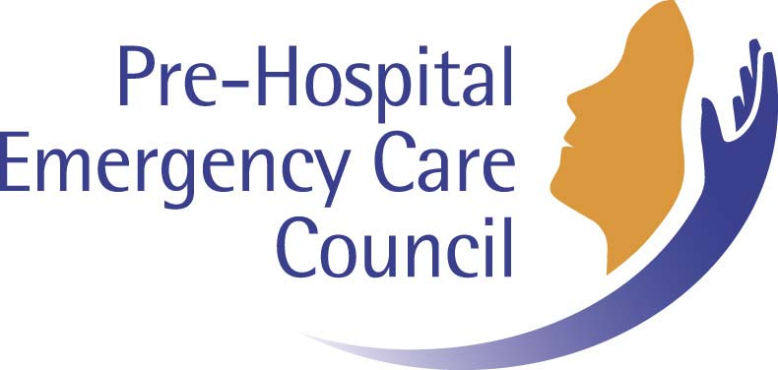

Council Policy and Procedures
for
Appeals

Document Management Data (To be removed prior to publication)
Title: POL019_Council Policy and Procedures for Appeals |  | V 2
Owner KW | Approved by: Council | Approval Date: Oct 2018

Mission Statement
“The Pre-Hospital Emergency Care Council protects the public by independently specifying, reviewing, maintaining and monitoring standards of excellence for the safe provision of quality pre-hospital emergency care”

©Pre-Hospital Emergency Care Council
Published by:

Pre-Hospital Emergency Care Council
Oct 2018

2nd Floor,
Beech House,
Millennium Park,
Naas Co Kildare, W91 TK7N,
Ireland.

T: + 353 (0)45 882042
E: info@phecc.ie
W: www.phecc.ie

Version History
(Please visit the PHECC website to confirm current version.)
Name: POL019_Council Policy and Prcedures for Appeals
Version | Date | Details
1 | Mar 2013 | New document on the Register
2 | Oct 2018 | Clarification of membership and revisions to Appendix 1 NQEMT Examination

Council Policy and Procedures for Appeals

Purpose
The purpose of this document is to set out the Pre-Hospital Emergency Care Council (“the Council”) policy and procedure for appeals against decisions of the Director.

Policy

It is the policy of the Council that all appeals are managed effectively in accordance with the procedures set out below.

Scope
This appeal procedure applies to decisions of the Director regarding:
- NQEMT Examination (Refer to Appendix 1)
- Recognition of Professional Qualifications including compensation measures (i.e. adaptation period and aptitude test)
- Registration
- Educational Awards (assistant tutor, tutor and facilitator)
- Recognition of Institutions and Courses
- Approval of Service Providers for CPGs
- Continued Competency
- Quality Review Framework
- Governance Validation Framework.

The Appeal Panel

Terms of reference
- The purpose(s) of the Appeal Panel:
  - consider appeals of decisions of the Director
  - to adjudicate on those appeals.
- A meeting of the Appeals Panel shall be quorate when 3 members are present.
- The Appeals Panel will conduct a comprehensive review of the appeal submission and thereafter complete a detailed written report regarding its decisions and accompanying rationale.
Membership: Appointed by Council
- The Appeals Panel shall consist of 7 members as follows:
  - Two Council Members
  - Patient Representative
  - Four other persons who are not Council members
- The Chair and Vice Chair will be Council members.

Governance and Accountability
- The terms of reference will initially be reviewed by the Appeals Panel at the end of the first year and thereafter at the end of Council’s term of office. Recommendations to modify the terms of reference will require approval of Council.
- Members must declare any conflict of interest to the Chair prior to the Panel hearing. In the case of the Chair declaring a conflict of interest the Vice Chair will serve.
- Only members of the Appeals Panel are to attend Panel hearings. No substitute members will be allowed. Other people, from time to time, as agreed by the Panel chairperson may be invited to attend a specific meeting, as appropriate.

Remuneration
No direct remuneration will be paid to Panel members. Expenses will be paid in accordance with the public service travel and subsistence policy. Expense forms must be submitted as per Council policy for expense payments.

Confidentiality
Panel members will ensure that they maintain the confidentiality of all information pertaining to the activities of the Appeals Panel.

Conduct of Appeal Hearing
- An appeal must be made in writing addressed to the Appeals Panel. The appeal must be sent by post or by hand to the PHECC office. Alternatively, it may be sent via email to info@phecc.ie. The appeal must be received by PHECC within 28 days of the date of the letter from PHECC informing of the decision which is being appealed.
- The appeal must include the appeal fee which can be enclosed or paid using PHECC’s electronic payment facility.

- The secretariat of the Appeals Panel will acknowledge receipt of an appeal.

- The appeal must clearly set out the grounds for the appeal. For example “I wish to appeal against the decision of PHECC because ”
- The appellant should state in his/her appeal whether the appellant requests the Appeals Panel to hear oral submissions from the appellant.
- In circumstances where oral submissions are not requested by the appellant, the Appeals Panel may request that oral submissions be made.
- The relevant officer within PHECC or a person appointed on his/her behalf may file replying submissions to the Appeals Panel setting out a response to the appeal. A copy of the PHECC submissions will also be sent to the appellant. The relevant officer within PHECC may request that the Appeals Panel hear oral submissions by or on behalf of PHECC at the appeal hearing.

- If oral submissions are not made to the Appeals Panel, the Appeals Panel will consider the appeal based on the content of the original PHECC file of the decision under appeal, documentation submitted by the appellant together with any submissions by or on behalf of the relevant officer within PHECC.

- Legal advice and administrative support as required will be made available to the Appeal Panel. Any legal advice received by the Panel will be shared by the Panel with the parties.
- The Appeals Panel will review all the documents set out at No. 7 above and may request additional information or may seek clarification from the parties.

- When the Appeals Panel is satisfied that they have sufficient information they will make a decision on each ground of appeal raised. In making its decision, the Panel may uphold, vary or overturn the decision which is being appealed.
- The Appeals Panel will write a report setting out their decision and reasons for the decision.

- The decision of the Appeals Panel is final except for appellants seeking recognition of qualifications in accordance with SI No. 8 of 2017- Recognition of Professional Qualifications. Such persons may appeal within 42 days to the High Court a decision made by the Appeals Panel.

- The appellant and the relevant officer within PHECC will be furnished with the report of the Appeals Panel.

APPENDIX 1

NQEMT Examination as outlined in Council Policy for National Qualification in Emergency Medical Technology

PHECC has set out below the circumstances where it will consider NQEMT Exam appeals.
- Only appeals of one of the following will be considered by the Appeals Panel:

  - That PHECC’s examination procedures, available in the NQEMT Examination Handbook, were not properly employed in the conduct of the examinations and that this procedural irregularity disadvantaged the appellant. For example, equipment failure in an OSCE or PC malfunctions not immediately rectified, e.g. by provision of a paper MCQ exam.

  - Extenuating circumstances, referring to a serious or unforeseen event in which the appellant suffered an illness or some personal or family trauma at the time of examination. The appellant must provide original medical certificates or other supporting information to support their case that extenuating circumstances apply. The illness or trauma must be shown to have affected them in the examination or in the period immediately leading up to it.

- If a student has cause to appeal a matter in relation to the Institution’s conduct of an NQEMT they should follow the Institution’s appeals and complaint procedures.
- The following circumstances will not be considered grounds for appeal and any such applications will be returned:
  - Perceived past shortcomings in tuition, supervision or support from the Recognised Institution. The Institution’s complaints procedures must be followed to address these issues as they arise.

  - The actual mark awarded for an examination. Being close to the pass mark is not grounds for appeal. If a student wishes to have clarification about results for a part of an examination, except the OSCE, an examination viewing and recheck can be considered.
- In circumstances where NQEMT Exam Appeals cannot be considered, as the circumstances are outside the rules of NQEMT examination appeal, unsuccessful NQEMT candidates can, under
  - Council Policy for NQEMT Examinations Viewings and Rechecks, seek to view the unsuccessful portion of their examination for educational purposes. Under the Viewings and Rechecks Policy, where a student wishes to challenge their results score, the recheck procedure exists to ensure that the marks and or answer matrix were properly applied.

  - In circumstances where a complaint is upheld the candidate will be informed. The Viewing and/or Recheck and/or Appeals fee/s will be refunded. All candidates who received a 0 mark and/or where the marks and/or answer matrix were not properly applied will be awarded the correct marks. Candidates will be deemed successful in the NQEMT examination, as appropriate.

Published by:
Pre-Hospital Emergency Care Council,
2nd Floor,
Beech House,
Millennium Park,
Naas Co Kildare, W91 TK7N,
Ireland.
Phone: +353 (0)45 882070
Email: info@phecc.ie
Web: www.phecc.ie

